**Linked-in**

**Issue 1 (Unable to Update Birthday Info for user with no bd data on creation step)**

(This is a bug I found and reported it to the linked team and it was resolved

Below is the conversation I had with linked team) .

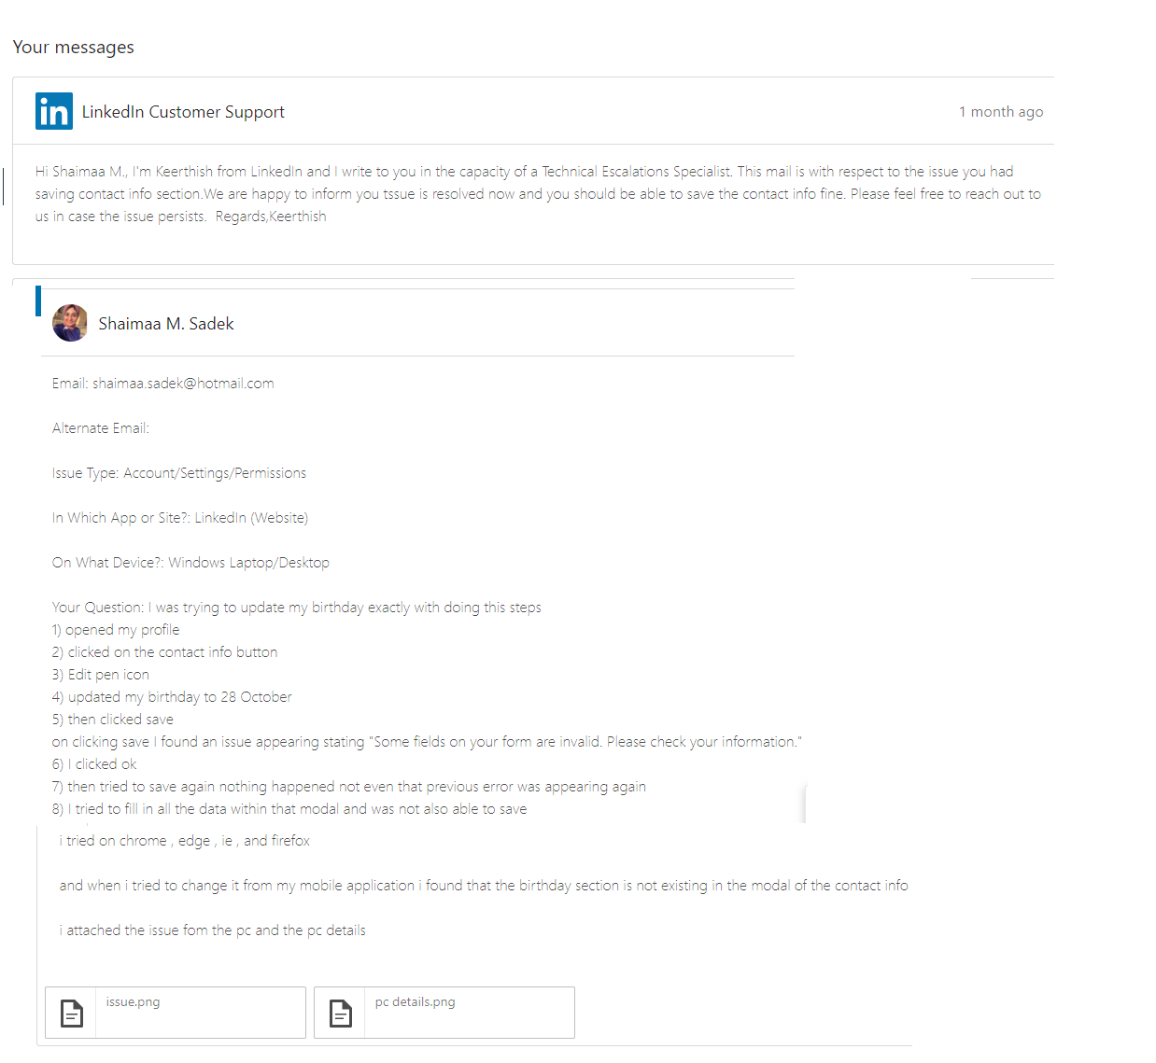

|  |  |  |
| --- | --- | --- |
| **Pre-Conditions:**  New Linked-in user signs up without adding his birthday in the registration form | **Test Data:**  Email : Valid Mail  Password: Valid password | **Priority: Severity :** Medium  High  **Issue Type:** Functional  **Devices/OS/Browsers:**  DesktopPc/MacOS/All Browser(Chrome-IE-edge-ff) |

|  |  |
| --- | --- |
| **Steps to reproduce:**  1)Login to Linked- in with the email & password>click on login.  2) Navigate to profile  3) in the contact info section , click on the edit pen icon  4) Change the birthday data  5)Click on Save | **Actual Results:**   * on clicking save an error message stops the system from saving the changes made in birthday field , and system freezes until user refreshes the page   Error message displayed is : “ some fields on your form is invalid ,check your information |

|  |  |
| --- | --- |
| **Screenshots:** |  |

**Issue Two ElMenus Mobile Application**

**Title :** User is Unable to Proceed with Ordering his choice on Android Devices

**Issue Type :** Functional/Usability **Priority:** High **Severity:** High

**Steps to Reproduce :**

1. Login with a valid Account
2. Click on Any restaurant > Make a Selection on any of the restaurant item
3. Attempt to proceed with your selection and change the screen

**Actual Result:**

1. There’s No Save order Button so that it navigates the user to another screen.
2. Order is not saved Hence user can never submit his item selection to checkout Cart.

|  |  |  |
| --- | --- | --- |
| **Device Details:** | **Screen shot:** |  |
| Huawei Mate 10 Lite Model(RNE-L21)  **OS :** Android Version 7.0  Reproduced on other android devices |  | User Cannot Save his Selections |

**Expected result :** User should Choose the items he needs and save or next button should be present , on clicking on this button Verifying the next screen should be saved and moves to another one “Based on UI Screens sequence expected “

**ISSUE 3 Facebook**

**Title:** Games Plugin integrating with FB is not Scrollable On Desktops/Mobile Tablets.

**Issue Type :**Integration/UI.

**Steps to Reproduce:**

* Login to fb Account
* From Explore section Click on Games> Click on Any Questions Game >

Attempt to scroll down to reach your results

**Actual results: Devices Affected :**

|  |  |
| --- | --- |
| User is not able to scroll down to reach  the remaining text , the screen context  is not correct on tablets and desktops. | Desktop OS windows  Screen Resolution “Lanscape” , 1366 x768  Tablet , Android OS Version 7.0, Lenovo |

**ScreenShots:** 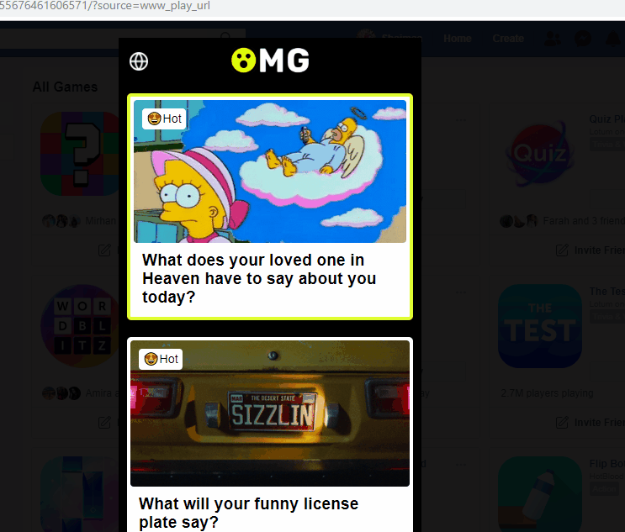

**Issue 4**

**On my previous Product (Upland Analytics)**

**Format from Jira( Contains , Steps, Priority, Sql Query Issued, Actual/Exp Results)**

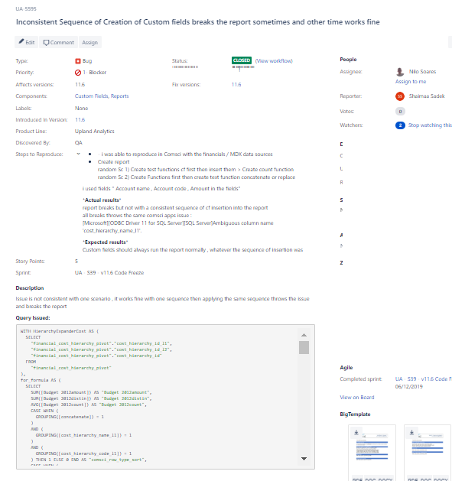

Issue 5 (Mobile Application I worked on as well)

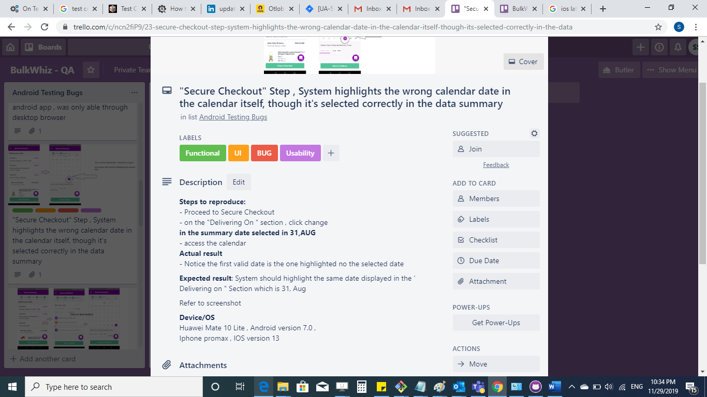

**\*\*Steps to reproduce:\*\***

- Proceed to Secure Checkout

- on the "Delivering On " section , click change

**in the summary date selected in 31,AUG** > access the calendar

**\*\*Actual result\*\***

- Notice the first valid date is the one highlighted no the selected date

**\*\*Expected result\*\***System should highlight the same date displayed in the ' Delivering on " Section which is 31, Aug

**\*\*Device/OS\*\***

Huawei Mate 10 Lite , Android version 7.0 ,

Iphone promax , IOS version 13

**Screenshot:**

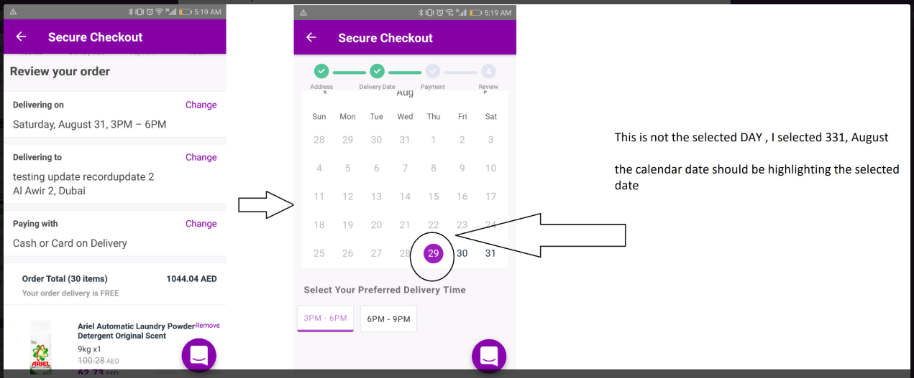

**Issue 6 (BulkWhiz E-commerce AI Mobile App I worked on)**

**Title :** Reset Password and resend link buttons are overlapping each other

**Screenshot:**

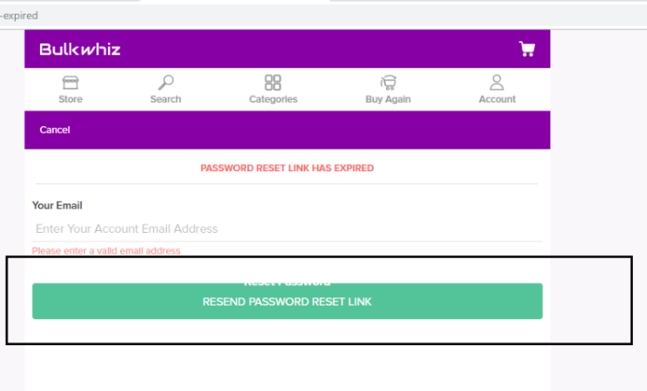

**Issue 6 (Linked-in)**

**Save for Later Feature**

**Title :** SAVE for later success tooltip text and dismiss button are not aligned

**Steps :** Login > Open News feed > Click on any post’s Settings > Select Save for later

Actual results: A tool tip is displayed with success text and dismiss button are not aligned together

**Expected results :**

Both button and text should be aligned together

**Screenshot:** 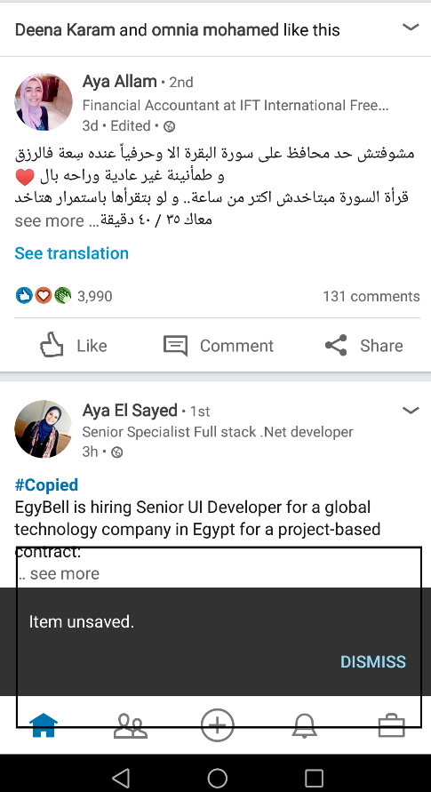

**Issue 7** Linked-In

**Title :(** Using Two Background Sessions with two different Accounts can sometime get the data of both accounts synchronized)

**Steps: >** Using Mobile Device open linked in mob app , And web app

* Log out from the session in mobile application then open the web application
* Then open the moile application again

**Actual results :**

In random cases you will find the profile picture of the user logged in web application is what’s being displayed in the mob ap newsfeed which is not the user’s image by any means

**Expected Results:**

Opening Multiple sessions with different accounts should not synchronize the data of the two accounts not on a random case , I was able to reproduce this 3 or 4 time in different times with different devices